Life and Living: Understand your own biology and that of other living things and recognise the interdependence of life.

Interrelationships Level Outcomes

Level 2:Describe the types of relationships between living things.

Few organisms live alone. They live together with members of their own species and with members of other species, often interacting with them. For example, animals may eat animals of other species, animals may compete for resources, some species, such as plants, help other species by providing food, shelter and shade.

Describe the following relationships between living things.

(a) Bees and flowers
_________________________________________________________________________________
_________________________________________________________________________________
_________________________________________________________________________________
_________________________________________________________________________________
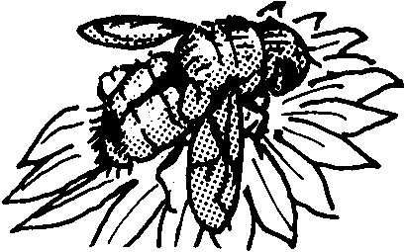
(b) A leaf and a caterpillar
_________________________________________________________________________________
_________________________________________________________________________________
_________________________________________________________________________________
_________________________________________________________________________________

(c) A flea and a dog
_________________________________________________________________________________
_________________________________________________________________________________
_________________________________________________________________________________
_________________________________________________________________________________

(d) A fungus and a rotting log
_________________________________________________________________________________
_________________________________________________________________________________
_________________________________________________________________________________
_________________________________________________________________________________

(e) An eagle and a rabbit
_________________________________________________________________________________
_________________________________________________________________________________
_________________________________________________________________________________
_________________________________________________________________________________

(f) Rabbits and sheep in a paddock
_________________________________________________________________________________
_________________________________________________________________________________
_________________________________________________________________________________
_________________________________________________________________________________

(g) Birds and trees
_________________________________________________________________________________
_________________________________________________________________________________
_________________________________________________________________________________
_________________________________________________________________________________
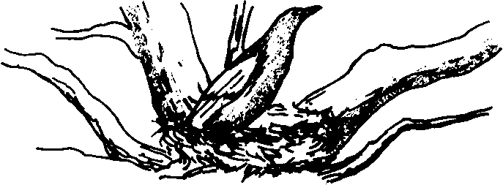

(h) Trees and grass growing in a field
_________________________________________________________________________________
_________________________________________________________________________________
_________________________________________________________________________________
_________________________________________________________________________________
- Groups of organisms of different species living together in a place and interacting are called communities.

Types of relationships

Many relationships between living things involve one organism eating or decomposing another. Other types of relationships also exist. They may be beneficial, harmful or neutral.

Find out about the following types of relationships.

1. Consumer - producer
_________________________________________________________________________________
_________________________________________________________________________________
_________________________________________________________________________________
_________________________________________________________________________________

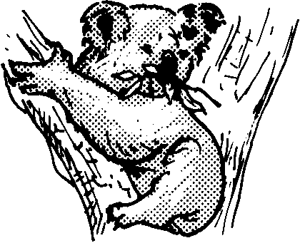
2. Predator – prey
_________________________________________________________________________________
_________________________________________________________________________________
_________________________________________________________________________________
_________________________________________________________________________________

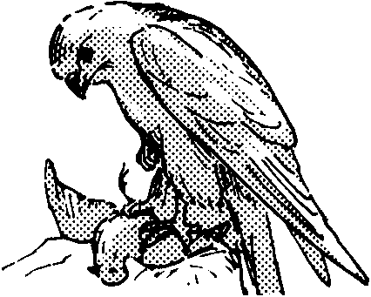
3. Decomposers
_________________________________________________________________________________
_________________________________________________________________________________
_________________________________________________________________________________
_________________________________________________________________________________

4. Competition
_________________________________________________________________________________
_________________________________________________________________________________
_________________________________________________________________________________
_________________________________________________________________________________

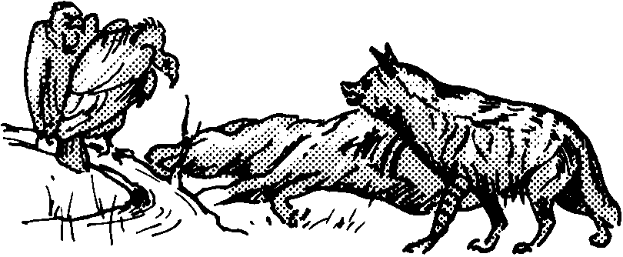
5. Parasite – host
_________________________________________________________________________________
_________________________________________________________________________________
_________________________________________________________________________________
_________________________________________________________________________________
6. Commensalism
_________________________________________________________________________________
_________________________________________________________________________________
_________________________________________________________________________________
_________________________________________________________________________________

7. Mutualism
_________________________________________________________________________________
_________________________________________________________________________________
_________________________________________________________________________________
_________________________________________________________________________________

